BUILD A WEB APPLICATION USING NODE-RED SERVICE

|  |  |
| --- | --- |
| **Team ID** | PNT2022TMID26519 |
| **Project Name** | SmartFarmer - IoT Enabled Smart Farming Application |
| **Team Members Name** | Monish Kumar V, Sanjay Kumar V , Mohana Priya K , Swetha G |

**Step:1** Go to Your Node-Red Flow Editor

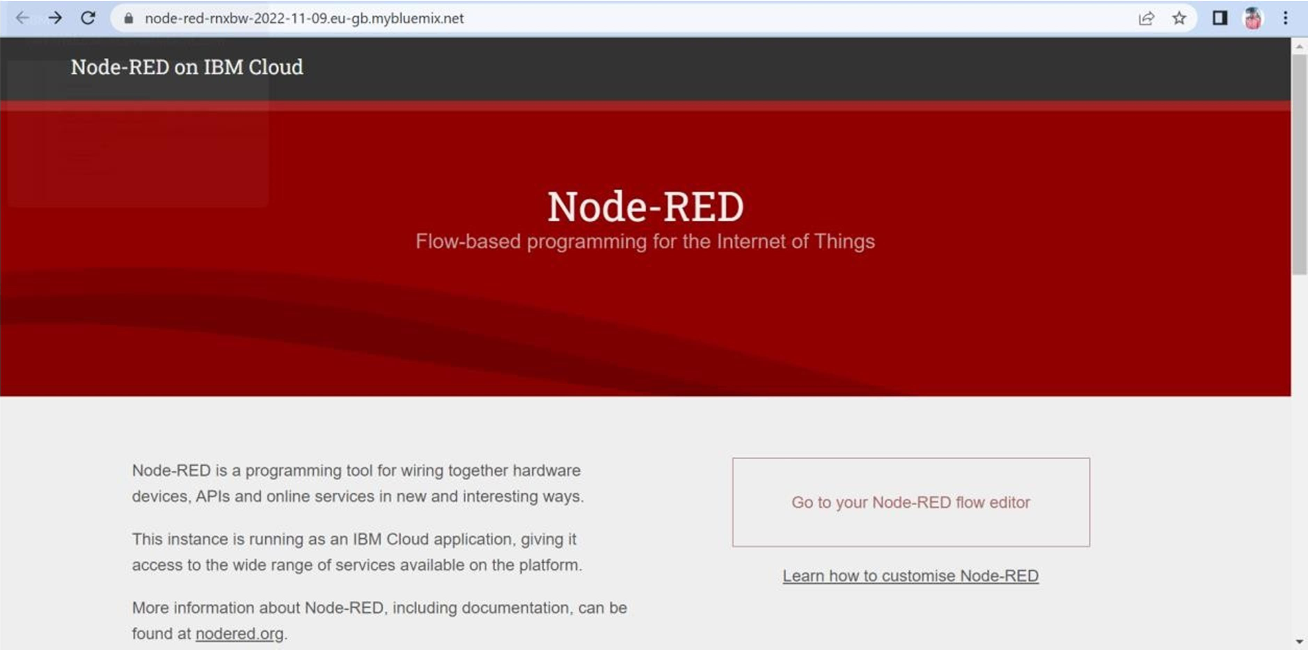

**Step:2** Design the Required flows to Create Web Application

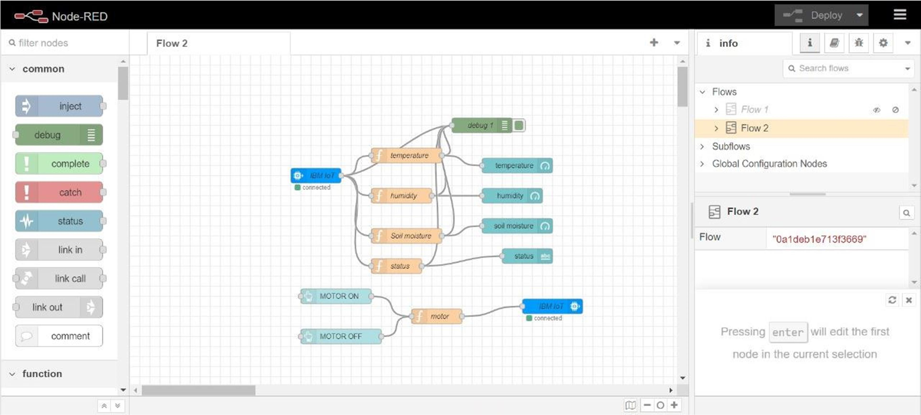



**Step:3** Getting the command From The user to Control the Motor

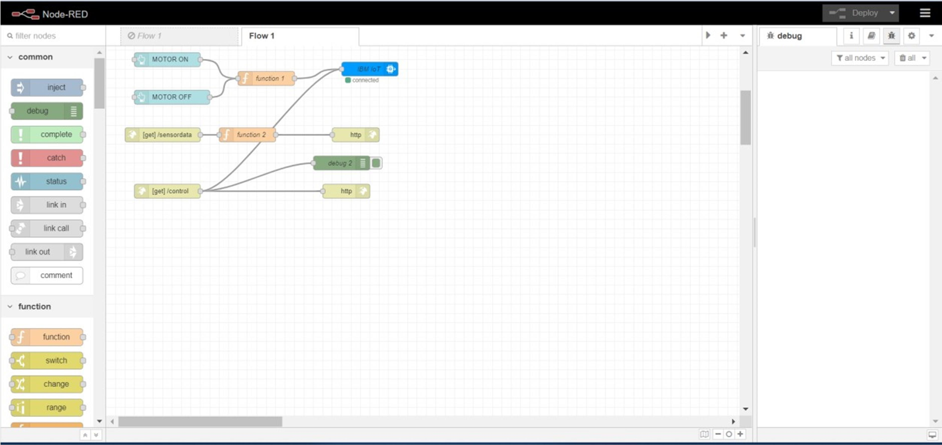

**Step:4** Temperature message Flow

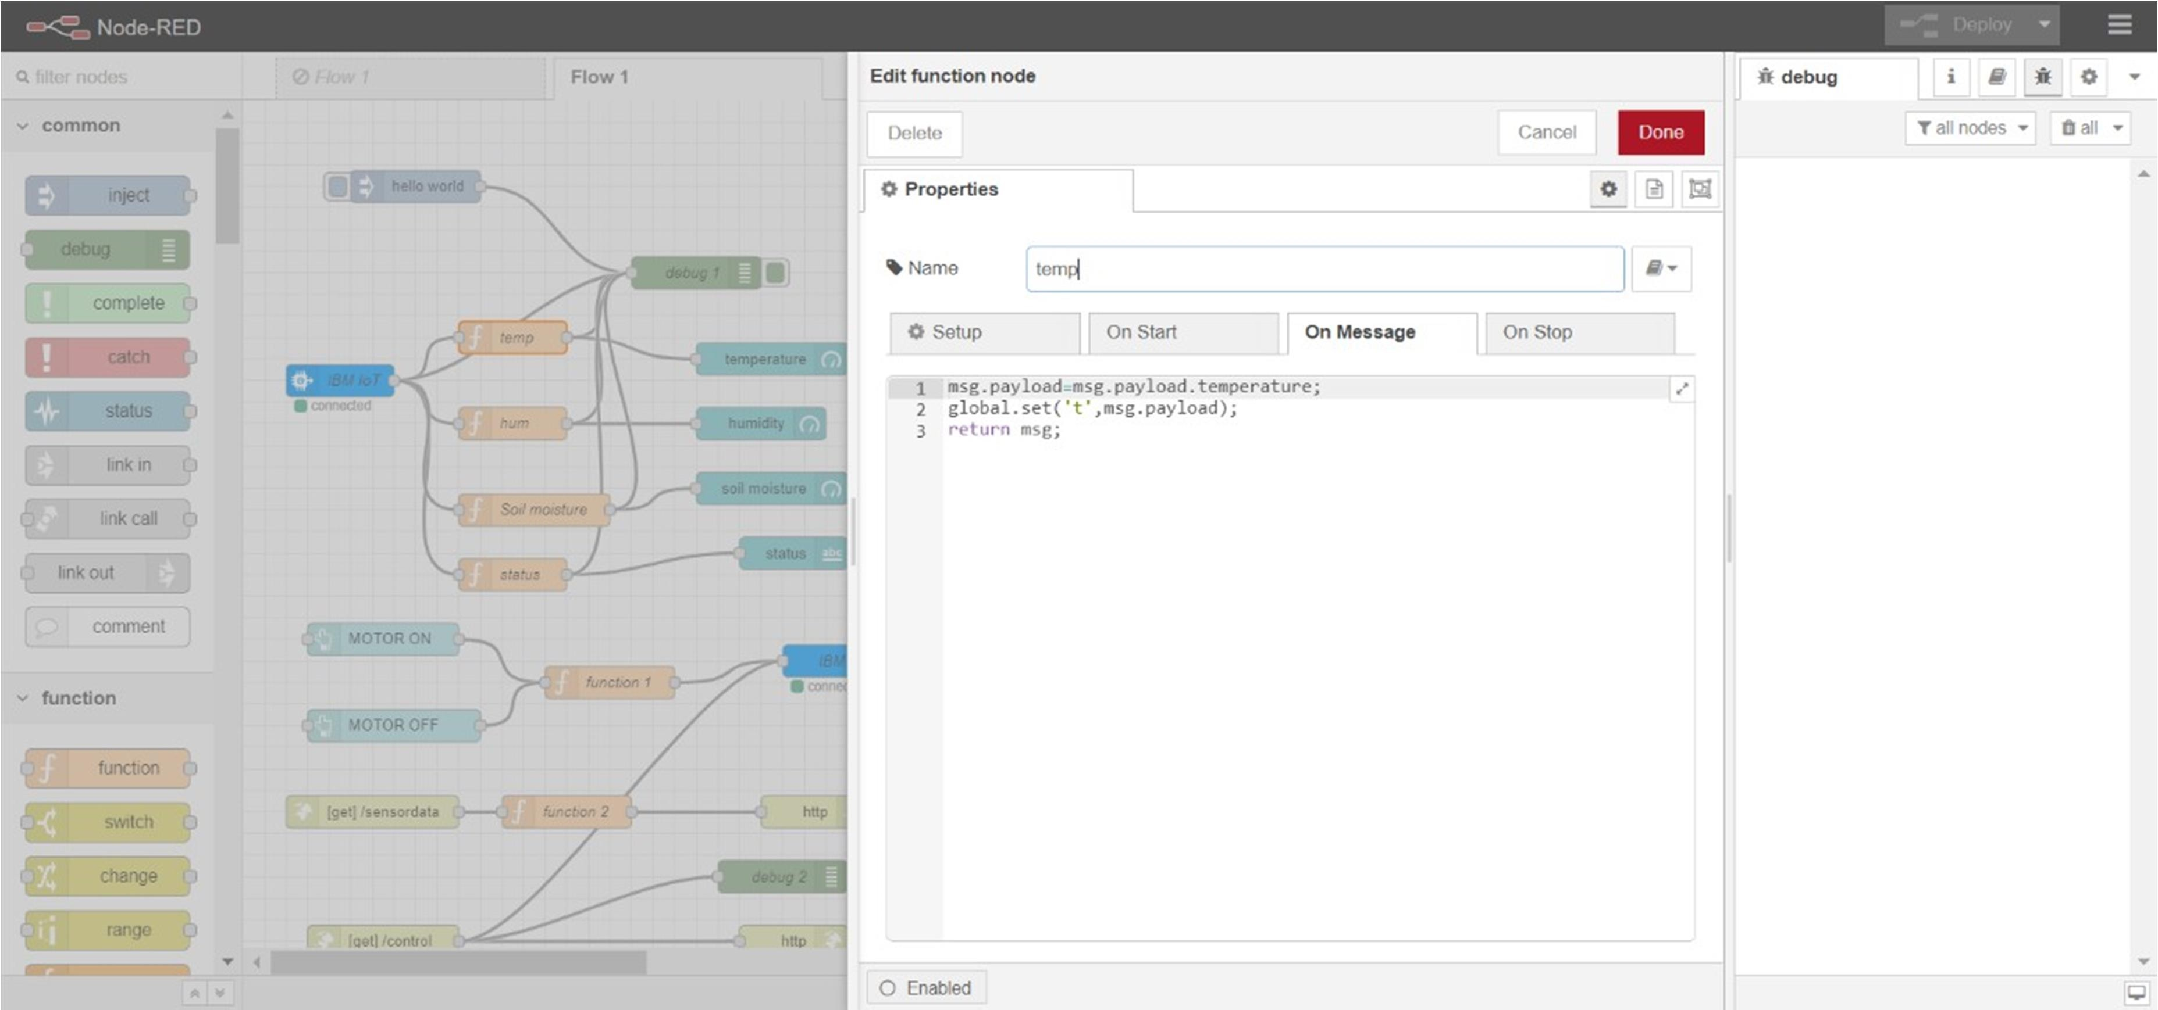



**Step:5** Humidity Message Flow

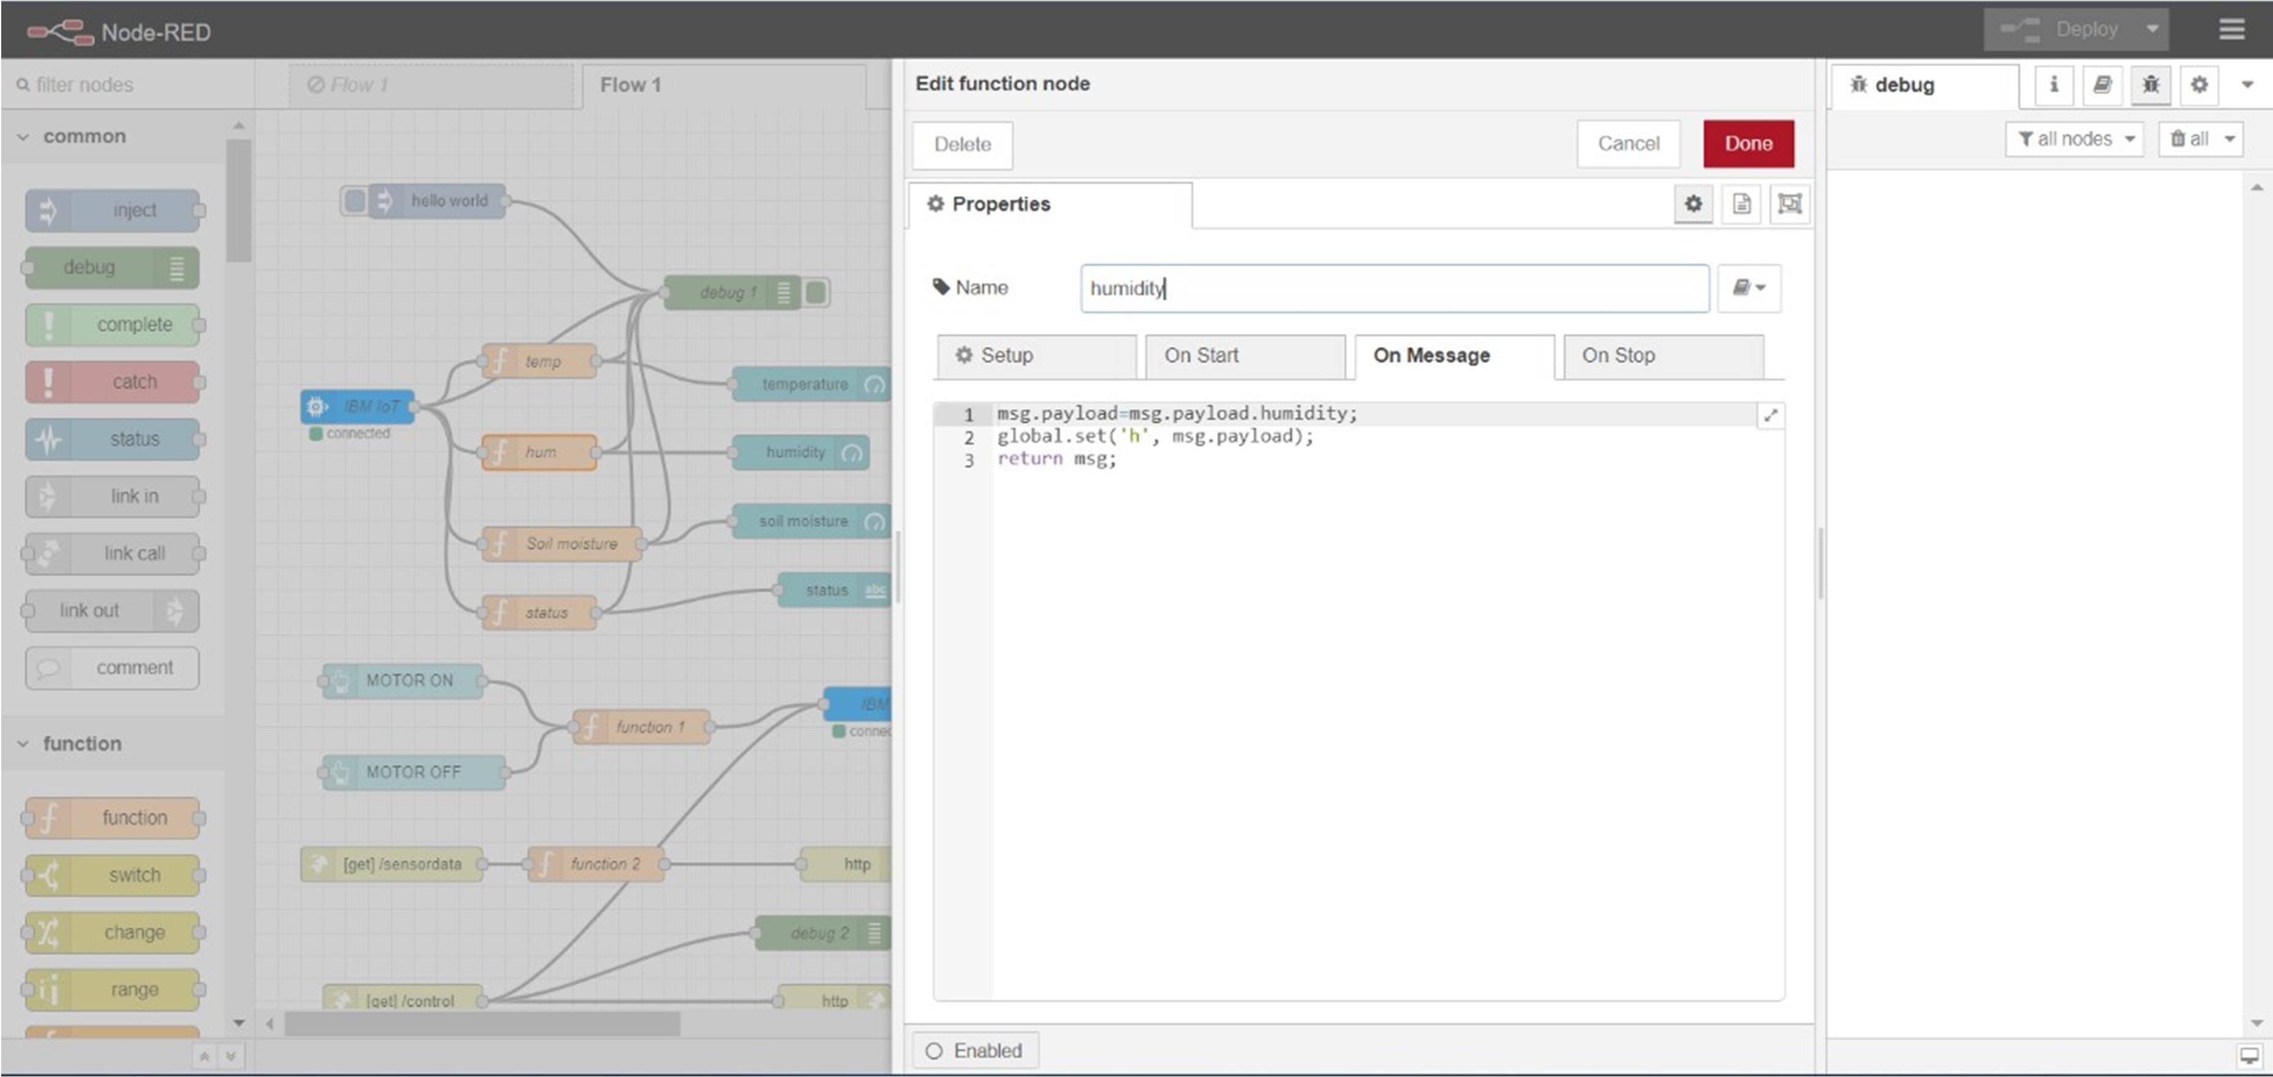

**Step:6** Soil Moisture Flow

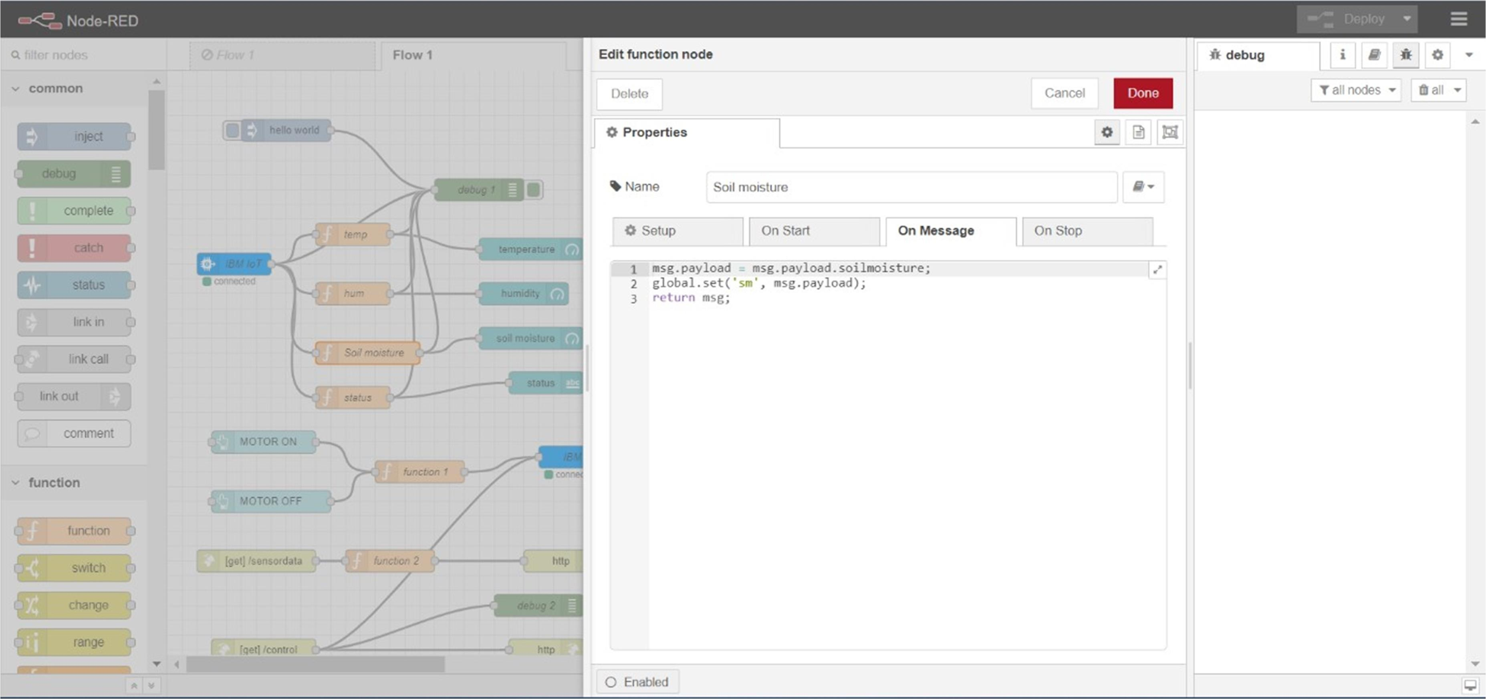

**Step:7** Final Web UI Output

